# Inspecting a DataFrame - Descriptive Statistics

This document includes the question, the solution, and a breakdown of the code provided in the screenshot.

## Uploaded Screenshot

Below is the screenshot of the task:

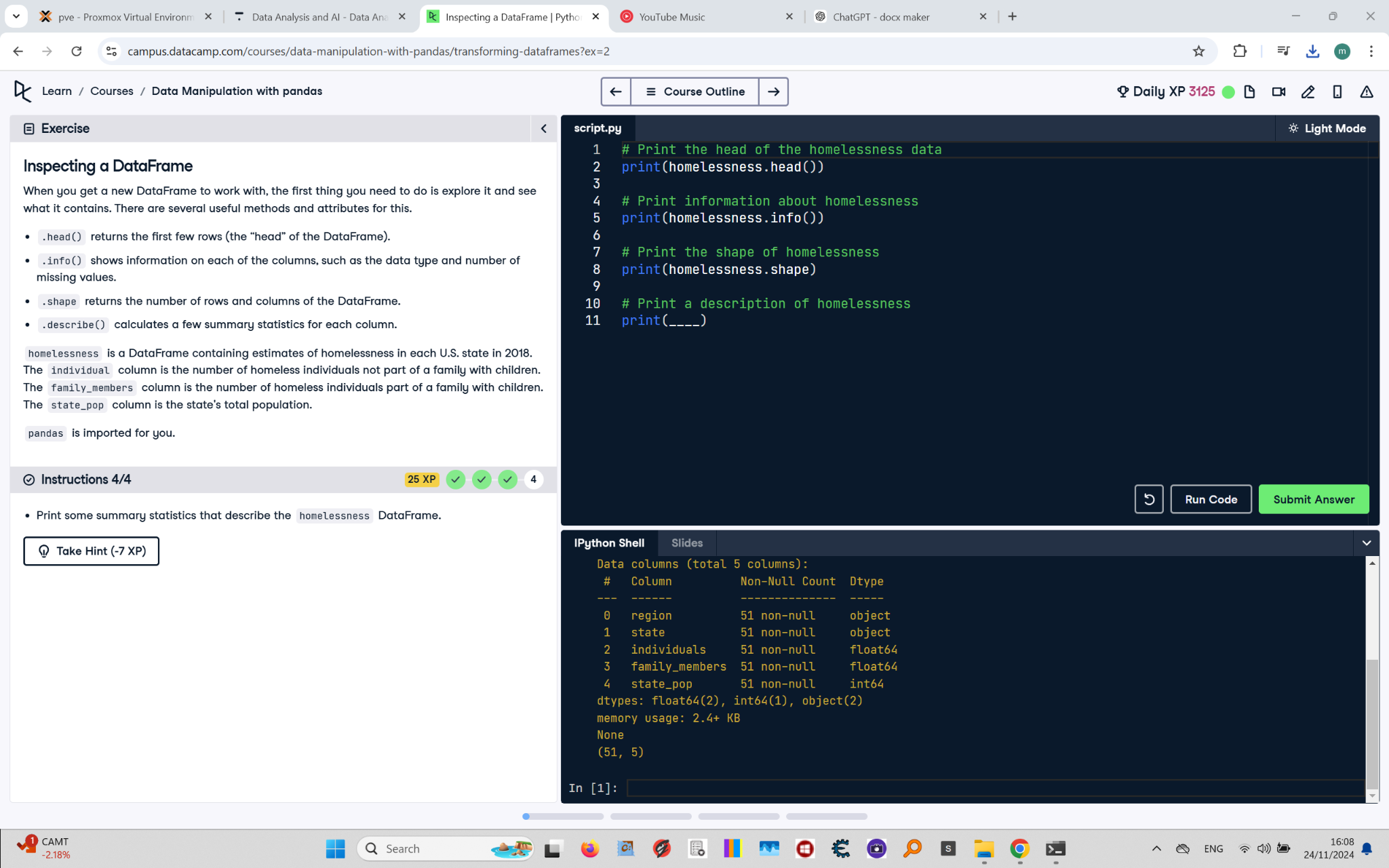

## Question

Print some summary statistics that describe the homelessness DataFrame.

## Answer

# Print the head of the homelessness data  
print(homelessness.head())  
  
# Print information about homelessness  
print(homelessness.info())  
  
# Print the shape of homelessness  
print(homelessness.shape)  
  
# Print a description of homelessness  
print(homelessness.describe())

## Code Explanation

# Explanation of the code:

1. `print(homelessness.head())`: Displays the first five rows of the DataFrame for a quick preview.

2. `print(homelessness.info())`: Provides detailed information about the columns, including data types and non-null counts.

3. `print(homelessness.shape)`: Outputs a tuple `(number_of_rows, number_of_columns)` representing the DataFrame dimensions.

4. `print(homelessness.describe())`: Computes and prints summary statistics for the numeric columns in the DataFrame, such as mean, standard deviation, min, max, and quartiles.